Bangkok 3Day2Night

Hight light: Dannea saduk floating Market / Songwat road Street art & food

Complementary coconut drink or Mango sticky rice

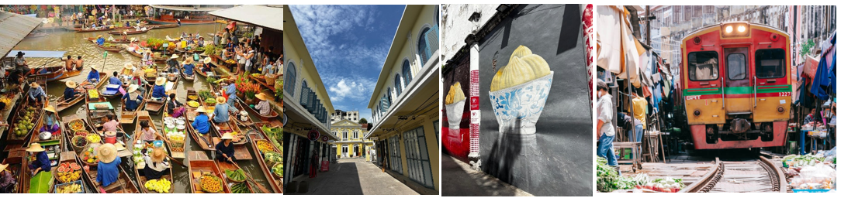

Booking code BKK-3D

3D2N Bangkok & Surroundings Tour

Day 1 – Arrival-Hotel

Arrival at Bangkok airport by representative at the airport. Transfer to hotel and check-in

Day 2 – Damnoen Saduak Floating Market & Maeklong Railway Market / Sonwat Art Street

- Breakfast at hotel

- Depart for Damnoen Saduak Floating Market – enjoy boat rides, local food, and souvenirs

- Visit Maeklong Railway Market – experience the unique train passing through the market

- Return to Bangkok, Visit Songwat Art Street – explore street art, local galleries, and cafes

- Platinum mall, Big Ce super market, Free time in the evening for shopping or leisure

- Evening at leisure or optional night market visit

Overnight in Bangkok

Day 3 – Departure

- Breakfast at hotel

- Free time for last-minute shopping or sightseeing

- Transfer to airport for departure

Validity: NOW - OCT’2026(Private Tours)

Hotel |  | Private Tour. TWN/TRP sharing  Currency: (THAI BAHT) |  |  |  |  | Extension  Room+ABF  /night | Extension  Extra+ABF  /night
 |  | 10+1 pax | 15+1 pax | 20+1 pax | 25+1 pax | Single supp | Twin /SGL | Extra Bed
Picnic Hotel (Standard) | *** | 5,200 | 4,300 | 3,800 | 3,200 | 1,700 | 1,700 | 600
Pannarai Hotel (Standard) | *** | 5,200 | 4,300 | 3,800 | 3,200 | 1,700 | 1,700 | 600
Baiyoke Boutique (Deluxe) | *** | 5,200 | 4,300 | 3,800 | 3,200 | 1,700 | 1,700 | 600
The Twin Towers Hotel (Sup) | *** | 5,200 | 4,300 | 3,800 | 3,200 | 1,700 | 1,700 | 600
Bangkok Midtown (Standard) | **** | 5,900 | 5,000 | 4,500 | 4,300 | 2,500 | 2,500 | 800
Baiyoke Suite (Superior) | **** | 5,900 | 5,000 | 4,500 | 4,300 | 2,500 | 2,500 | 800
Pure Eleven Hotel (Superior) | **** | 5,900 | 5,000 | 4,500 | 4,300 | 2,500 | 2,700 | 1,000
Vince Pratunam (Superior) | **** | 5,900 | 5,000 | 4,500 | 4,300 | 2,500 | 2,700 | 1,000
Mercure makasan ( Superior) | **** | 5,900 | 5,000 | 4,500 | 4,300 | 2,500 | 2,700 | 1,000
Centara Watergate (Superior) | **** | 6,400 | 5,500 | 5,000 | 4,700 | 3,200 | 3,500 | NO
Center Point Pratunam(Grand Deluxe) | **** | 6,400 | 5,500 | 5,000 | 4,700 | 3,200 | 3,500 | 1,000
The Berkeley Pratunam(Premier) | **** | 6,400 | 5,500 | 5,000 | 4,700 | 3,200 | 3,500 | NO
Armona Grand (Superior) | **** | 6,400 | 5,500 | 5,000 | 4,700 | 3,500 | 3,500 | 1,500
Baiyoke Sky Hotel (Superior) | **** | 6,400 | 5,500 | 5,000 | 4,900 | 3,200 | 3,500 | 1,500
Amari Watergate (Deluxe) | ***** | 7,900 | 7,000 | 6,500 | 6,300 | 5,000 | 4,700 | 1,500
Novotel Platinum (Superior) | **** | 7,900 | 7,000 | 6,500 | 6,300 | 5,000 | 4,700 | 1,500
Novotel Siam (Superior) | **** | 7,900 | 7,000 | 6,500 | 6,300 | 5,000 | 4,700 | 1,500
Moxy Ratchaprasong by Marriott | ***** | 7,900 | 7,000 | 6,500 | 6,300 | 5,000 | 4,700 | NO

Remark: -
Child share twin same rate adult fare.
Child with bed 75 %.
Child No bed 50% (5–10-year-old)
Compulsory tipping guide THB 100 per person.

Hotel Surcharge:
- Peak Season Supplement (28 Dec 2026 – 2 Jan 2027) +THB 500.-net/room/night (4-5 star)
- Chinese New Year Supplement (04-08 February’26) +THB 500.-net/room/night (4-5 star)

Package includes
- Hotel 2night with breakfast
- Transport round trip (Apt-Htl-Apt) *By Bus*
- One day tour no meal / Tourist insurance
- English or Chinese speaking guide service.

Remark: For Extension night include transfer to Airport

TERM AND CONDITIONAL:
- Price quote in Thai Bath (THB)
- Above tour fare is for Asian Nationality only.
- Table setting for Thai Restaurant will be set as 4pax/table/set or 6pax/table/set meal, Chinese set dinning will be set 8-10 pax/table/set.
- ALL RESTAURANTS MAY BE CHANGED WITHOUT PRIOR NOTICE.
- In case the Hotel envisages or normal categories of Rooms are wait listed / sold out, alternate hotel/category. Will be provided & we will keep you informed on the supplement / reduction involved.
We have NOT booked any rooms at any hotels mentioned; once we received confirmation from you will check the rooms available and book rooms at all above.
- The cost is based on mentioned above paying pax travelling, any addition or reduction in the number of pax would change the cost accordingly.
- All hotel check in 14.00 p.m. and check out time is 12.00 pm.
- Prices are subjected to change without prior notice, in case of fluctuation in exchange rate or increase in fuel surcharge.


Transfer service as below
If you need any questions about this package please CONTACT
MS.fon HP+6694-5469539 / MS AMEE HP+6692-2518492/ MS ELIN HP+6017688 6001
Email: ggm.thaitravel@gmail.com , ggm.managerthaitravel@gmail.com , ggmthaimanagement@gmail.com

Thank you for your away support us!

